“Inspire-Vibes”

A Minor Project Report

*Submitted By*

KESHAV VIJAY 21BCON401

Section - J

*In partial fulfillment for the award of the degree*

*of*

**BACHELOR OF TECHNOLOGY**

IN

**COMPUTER SCIENCE & BUSINESS SYSTEMS**

**AT**



JECRC UNIVESITY, JAIPUR

Dec 15, 2023

**Candidate’s Declaration**

I**, Keshav Vijay**, bearing roll number **21BCON401**, hereby declare that the work which is being presented in the Minor Project, entitled “**InspireVibes**” in partial fulfilment for award of Degree of “**Bachelor of Technology**” in Department of **Computer Science and Business system** is submitted to the Department Computer Science & Engineering, JECRC University is a record of Minor Project work carried under the Guidance of Ms. **Shivangi Dheer**, Department Computer Science & Engineering.

I have not submitted the matter presented in this work anywhere for the award of any other Degree.

Keshav Vijay

21BCON 401

Computer Science

**JECRC UNIVERSITY JAIPUR**

*Ramchandrapura, Sitapura Industrial Area Extn, Jaipur-303905(Raj.) India* *[www.jecrcuniversity.edu.in](http://www.jecrcuniversity.edu.in/)*

Date: Dec 15, 2023

**CERTIFICATE**

Certified that the Project Report entitled “**InspireVibes**” submitted by Keshav Vijay bearing roll no. 21BCON401 . In partial fulfilment of the requirements for the award of the degree of Bachelor of Technology of JECRC University, Jaipur is a record of the student’s own work carried out under my supervision and guidance. To the best of our knowledge, this Minor Project work has not been submitted to JECRC University or any other university for the award of the degree. It is further understood that by this certificate the undersigned does not endorse or approve of any statement made, opinion expressed or conclusion drawn therein but approve Minor Project for the purpose for which it is submitted.

Ms. Shivangi Dheer

**ACKNOWLEDGEMENTS**

Many people have supported me, in different ways, during the work with the project. I’d like to thank my guide Ms. Shivangi Dheer for her kind and active support and valuable guidance during the work process. My family has as always offered me their unconditional support, thank you! I have taken efforts in the Minor Project. However, it would not have been possible without the kind support and many individuals and organizations. I would like to extend my sincere thanks to each and every members related to JECRC University.

Keshav Vijay

21BCON401

**ABSTRACT**

InspireVibes is a digital sanctuary crafted to inspire, motivate, and foster personal growth. This online platform is dedicated to cultivating a community where individuals can freely express themselves, share motivational insights, and embark on transformative journeys of self-discovery.

At the heart of InspireVibes is a commitment to creating an aesthetically pleasing and user-friendly environment. Through a curated blend of motivational content, interactive forums, and engaging multimedia, users are invited to join a community that vibrates with positive energy and encouragement.

Our mission at InspireVibes is to empower individuals to unlock their full potential, connect with like-minded souls, and navigate the path to personal fulfillment. Whether through thought-provoking articles, uplifting success stories, or interactive discussions, InspireVibes invites users to become part of a dynamic and supportive network dedicated to uplifting the human spirit.

Join InspireVibes today and embark on a journey where your voice matters, your aspirations are celebrated.

**TABLE OF CONTENT**

1. INTRODUCTION
2. PURPOSE
3. PROJECT SCOPE
4. LITERATURE SURVEY
5. SOFTWARE REQUIREMENT ANALYSIS
6. ADVANTAGES
7. GOAL AND GUIDELINES
8. DESCRIPTION OF CONCEPT
9. SOFTWARE DESIGN

10. SOFTWARE AND HARDWARE REQUIREMENTS

11. DESIGN DESCRIPTION

* 1. OBJECTIVE
  2. CLASS DIAGRAM
  3. USECASE DIAGRAMS

12. INTERFACE(FINAL PROGRAM)

1. CODE
2. OUTPUT(ATTACHMENTS OF WEBSITE)

13. TESTING

**INTRODUCTION**

**Background**

In a world characterized by constant change and challenges, there arises a growing need for platforms that not only inspire but also foster genuine connections and personal development. InspireVibes emerges as a response to this need, aiming to create a digital haven where individuals can embark on journeys of self-discovery, share motivational insights, and connect with a supportive community.

The Inspiration Behind InspireVibes:

InspireVibes is born out of a vision to empower individuals to overcome obstacles, embrace their authentic selves, and contribute to a positive and uplifting collective. The idea is rooted in the belief that a community-driven approach to personal growth can create a ripple effect of positivity and inspiration.

The Unique Offering:

Unlike generic self-help platforms, InspireVibes stands out with its emphasis on aesthetics and user experience. The platform is designed to be visually appealing, creating an inviting atmosphere that encourages users to freely express themselves and engage in meaningful conversations. The combination of curated motivational content and interactive features sets InspireVibes apart as a dynamic space for personal and communal growth.

The Community Philosophy:

At the core of InspireVibes is a commitment to building a community that resonates with positive energy. Users are invited to share their stories, insights, and challenges, creating a collective tapestry of inspiration. The platform's interactive forums and multimedia elements facilitate genuine connections, making InspireVibes not just a website but a supportive digital family.

The Journey Ahead:

InspireVibes is not merely a project; it's a movement toward fostering a culture of positivity and self-discovery. As users engage with the platform, the aim is to create a ripple effect, inspiring individuals to make positive changes in their lives and, in turn, contribute to a more uplifting and connected global community.

Join us on the journey as we launch InspireVibes, where each interaction, story shared, and moment of inspiration contributes to a collective symphony of positive vibes and personal growth.

**Statement of the problem**

In today's fast-paced and interconnected world, individuals face a myriad of challenges that can impede personal growth and well-being. Despite the wealth of digital platforms, there exists a distinct need for a dedicated space that goes beyond mere self-help, providing a dynamic and aesthetically pleasing environment for individuals to express themselves, find motivation, and connect with like-minded individuals. The absence of such a platform leaves a void in the digital landscape, hindering the potential for a community-driven approach to personal development.

Key Issues:

**Lack of Positive and Aesthetic Online Spaces:**

Existing online platforms often lack a cohesive focus on positivity, aesthetic appeal, and a community-driven atmosphere. This deficiency diminishes the user experience and inhibits the formation of a supportive community.

Isolation in Personal Growth Journeys:

Many individuals navigating personal development journeys do so in isolation, lacking a platform where they can freely express themselves, share insights, and receive encouragement from a like-minded community.

**Objective of the study:**

1. **Create a Positive and Inclusive Digital Community:**

Establish a welcoming online community that fosters positivity, inclusivity, and a sense of belonging, encouraging users to freely express themselves in a supportive environment.

2**. Provide a Platform for Self-Expression and Personal Growth:**

Enable users to embark on personal development journeys by offering a platform where they can share their stories, insights, and motivational content, contributing to their individual growth and inspiring others.

3. **Curate High-Quality and Aesthetically Pleasing Content:**

Curate and deliver engaging, high-quality content that not only motivates but also captures the attention through an aesthetically pleasing and user-friendly design.

4. **Facilitate Meaningful Connections and Interactions:**

Foster genuine connections among users through interactive forums, discussions, and multimedia elements, promoting a sense of community and shared growth.

5**. Encourage Active Participation and Contribution:**

Inspire users to actively participate in the platform by sharing their experiences, contributing motivational content, and engaging in positive interactions, creating a dynamic and thriving digital space.

**PURPOSE OF PROJECT**

The purpose of the InspireVibes project is to establish a transformative online sanctuary dedicated to empowering individuals on their journeys of self-expression, motivation, and personal development. In a digital landscape often saturated with conventional self-help platforms, InspireVibes seeks to redefine the experience by prioritizing positivity, inclusivity, and aesthetics. Our primary goal is to cultivate a community-driven environment where users can authentically express themselves, share motivational insights, and engage in meaningful connections with like-minded individuals.

InspireVibes is driven by the belief that personal growth is enhanced in a supportive and visually engaging space. By curating high-quality content, promoting user-friendly design, and emphasizing aesthetic appeal, the project aims to make the pursuit of personal development not only enriching but also enjoyable. Through interactive forums, multimedia elements, and a commitment to fostering a positive atmosphere, InspireVibes aspires to transcend the limitations of traditional self-help platforms.

**PROJECT SCOPE**

Inspire-Vibes is envisioned as a digital haven fostering personal growth, self-expression, and motivation. The project encompasses the creation of a user-friendly website featuring interactive forums and an aesthetically pleasing design. Central to its scope is the curation and publication of motivational content, including articles and multimedia elements.

The platform will facilitate real-time user interactions, employ analytics to measure engagement, and incorporate features promoting an inclusive and positive community. Emphasis is placed on a visually appealing design to enhance user experience. Continuous improvement, guided by user feedback and analytics, is integral. The project operates within budgetary and legal constraints, with success gauged through metrics like user engagement, positive feedback, and community expansion.

**LITERATURE SURVEY**

A literature survey for the InspireVibes project involves reviewing existing research on community-driven platforms, user experience design, the impact of positive content on well-being, effective user engagement strategies, global online communities, success factors for online platforms, iterative development based on user feedback, branding and trust building, social media's role in community building, the psychology of user engagement, and technological trends. By synthesizing insights from diverse sources, the literature survey will inform the project's design, features, and strategies for fostering a positive and engaging online community.

**SOFTWARE REQUIREMENT ANALYSIS**

Inspire-Vibes, the software requirement analysis would involve identifying and documenting the specific needs and features essential for the development of the platform. Here's an overview tailored for your project:

User Requirements Elicitation:

Objective: Understand the expectations and needs of users for the InspireVibes platform.

Activities: Conduct interviews, surveys, and feedback sessions with potential users to gather insights into the desired features, user experience expectations, and community engagement preferences.

Functional Requirements Documentation:

Objective: Clearly define the functionalities and features that InspireVibes will offer to its users.

Activities: Document user stories, use cases, and functional requirements that encompass content creation, user profiles, community forums, motivational content curation, and interactive features.

Non-functional Requirements Specification:

Objective: Identify and document non-functional aspects critical to the platform's performance.

Activities: Specify requirements related to performance, scalability, security, and accessibility. For example, define response times, user load capacity, encryption standards, and accessibility compliance.

Prototyping and Mockups:

Objective: Visualize the user interface and overall user experience.

Activities: Develop wireframes or mockups illustrating the platform's layout, features, and navigation. Use these prototypes to gather early feedback from stakeholders and refine the design.

User Engagement and Community Building:

Objective: Define features that encourage user engagement and foster a positive community.

**ADVANTAGES**

The InspireVibes project brings several advantages to its users and the broader online community:

Positive Community Building:

Advantage: InspireVibes fosters the creation of a positive and supportive online community where individuals can connect, share their journeys, and uplift each other.

Personal Development Focus:

Advantage: The platform is dedicated to personal development, providing users with motivational content, insights, and tools to navigate their unique journeys of self-improvement.

Aesthetic and User-Friendly Design:

Advantage: InspireVibes prioritizes an aesthetically pleasing and user-friendly design, enhancing the overall user experience and making personal development an enjoyable and visually engaging experience.

Global Reach and Inclusivity:

Advantage: The platform is designed to be accessible globally, transcending geographical boundaries. It embraces inclusivity by considering diverse cultural backgrounds and languages.

Interactive Features for Engagement:

Advantage: InspireVibes incorporates interactive features such as forums, challenges, and user-generated content to encourage active participation and engagement within the community.

Feedback Mechanism for Continuous Improvement:

Advantage: The platform includes a feedback mechanism, allowing users to share their opinions and contribute to continuous improvement. This ensures that the platform evolves based on user needs and preferences.

GOAL AND GUIDELINES

**Goal of Inspire-Vibes**:

The primary goal of Inspire-Vibes is to create a transformative online platform dedicated to empowering individuals on their journeys of self-expression, motivation, and personal development. It aims to establish a positive and inclusive digital community where users can freely express themselves, share motivational content, and engage in meaningful interactions that contribute to their individual growth and inspire others.

**Guidance for Inspire-Vibes:**

Positive Community Building:

Foster a community-driven environment that prioritizes positivity, inclusivity, and mutual support.

User-Centric Design:

Prioritize an aesthetically pleasing and user-friendly design to enhance the overall user experience.

Content Curation:

Curate and deliver high-quality content that aligns with the platform's mission and resonates with the target audience.

Interactive Features:

Implement interactive features such as forums, challenges, and user-generated content to encourage active participation and engagement.

Continuous Improvement:

Embrace an iterative development approach, actively seeking and incorporating user feedback to enhance features and content.

Global Reach and Inclusivity:

Design the platform to be accessible globally, considering diverse cultural backgrounds and languages to ensure inclusivity.

**DESCRIPTION OF CONCEPT**

InspireVibes is a visionary digital platform dedicated to inspiring personal growth, motivation, and self-expression. At its core, the concept revolves around cultivating a positive and supportive online community where individuals from diverse backgrounds come together to share their journeys, uplift one another, and embark on a collective pursuit of self-improvement. The platform is meticulously designed with a user-centric approach, combining functionality with aesthetic appeal to offer an immersive and enjoyable experience. InspireVibes curates a diverse array of content, including motivational articles, success stories, and multimedia elements, fostering a rich environment for personal development exploration.

A cornerstone of the InspireVibes concept is the careful curation of diverse content. This includes motivational articles, success stories, and a rich tapestry of multimedia elements, creating an environment that encourages exploration and discovery on the path to personal development. The interactive features embedded within the platform, such as discussion forums and user-generated content opportunities, foster an engaged and participatory community, elevating the digital experience to a dynamic and collaborative level.

With a commitment to inclusivity and a global perspective, InspireVibes reaches beyond geographical confines, embracing individuals from various cultural backgrounds. The platform operates on an iterative development model, placing a premium on user feedback to drive continuous improvement, adaptability to evolving needs, and a steadfast dedication to delivering an ever-enhancing user experience.

InspireVibes transcends the realm of a mere digital platform; it aspires to be a positive force contributing to the mental and emotional well-being of its users.

**SOFTWARE DESIGN**

1. Architectural Overview:

Description: Adopt a microservices architecture for scalability and maintainability.

Components:

* User Interface (UI)
* User Profiles
* Content Management System
* Community Forums
* Interactive Features

Feedback Mechanism

2. User Interface Design:

Description: Prioritize an intuitive and visually appealing user interface.

Features:

* Clear navigation
* Personalized user profiles
* Engaging visual elements
* Responsive design for various devices

3. User Profiles and Personalization:

Description: Enable users to personalize their experience.

Features:

* Profile creation and customization
* Goal-setting and progress tracking
* Social connectivity within the platform

4. Content Management System:

Description: Develop a robust system for content creation and curation.

Features:

* Authoring tools for content creators
* Categories for different types of content
* Version control for content updates

5. Community Forums and Interactive Features:

Description: Foster user engagement through interactive features.

Features:

* Discussion forums
* Challenges and activities
* User-generated content sharing

6. Security Measures:

Description: Implement robust security practices to protect user data.

Security Features:

* Secure user authentication
* Data encryption in transit and at rest
* Access controls and permissions

7. Scalability Considerations:

Description: Design for scalability to accommodate a growing user base.

Strategies:

* Load balancing
* Database sharding

Serverless architecture for specific functions

8. Feedback Mechanism:

Description: Integrate a user-friendly feedback system.

Features:

* Ratings and comments on content
* User surveys for platform improvements
* Real-time feedback options

**SOFTWARE AND HARDWARE REQUIREMENTS**

Software Requirements:

Development Environment:

1. Integrated Development Environment (IDE):
   * Visual Studio Code.
2. Version Control:
   * Git for version control.
   * GitHub for repository hosting.
3. Programming Languages:
   * JavaScript for frontend development.
   * Node.js for server-side development.
   * Database query language ( SQL for relational databases).
4. Web Technologies:
   * HTML5, CSS3 for frontend development.
   * React.js or Vue.js for building the user interface.
   * Express.js or Nest.js for backend development.
5. Database:
   * MongoDB or MySQL for data storage.
   * Database management tool (e.g., MongoDB Compass, MySQL Workbench).
6. Content Management:
   * Headless CMS (e.g., Strapi) if applicable.
7. Authentication:
   * Authentication library or framework (e.g., Passport.js).
   * OAuth 2.0 for third-party login integration.
8. Security:
   * SSL/TLS for secure communication.
   * Security libraries (e.g., Helmet.js) for HTTP header security.
9. Testing:
   * Jest or Mocha for unit testing.
   * Testing library (e.g., React Testing Library) for UI testing.
   * Supertest or Postman for API testing.
10. Documentation:
    * Swagger or OpenAPI for API documentation.
    * Markdown for general documentation.
11. Containerization:
    * Docker for containerization.
    * Docker Compose for multi-container setups.
12. Continuous Integration/Continuous Deployment (CI/CD):
    * Jenkins, GitLab CI, or GitHub Actions.
13. Collaboration:
    * Communication tools (e.g., Slack, Microsoft Teams).
    * Project management tools (e.g., Jira, Trello).

**Hardware Requirements:**

Development Machines:

1. Development PCs:
   * Minimum: Dual-core processor, 8GB RAM, 256GB SSD.
   * Recommended: Quad-core or higher, 16GB RAM, 512GB SSD.
2. Operating System:
   * Windows, macOS, or Linux.

Deployment Environment:

1. Web Server:
   * Nginx or Apache for serving frontend assets.
2. Database Server:
   * Based on the chosen database technology.
3. Hosting/Cloud Service:
   * AWS, Google Cloud Platform, Azure, or other cloud providers.
   * Alternatively, a dedicated server if self-hosting.
4. Domain and SSL Certificate:
   * Domain for the platform.
   * SSL certificate for secure communication (can be obtained from Let's Encrypt or other providers).

**DESIGN DESCRIPTION**

* 1. **OBJECTIVE**

The objectives of the InspireVibes platform are rooted in creating a positive and transformative digital space that empowers individuals on their personal development journeys. The platform aims to achieve the following key objectives:

Foster Personal Growth:

Objective: Provide users with a supportive environment that encourages continuous personal development. InspireVibes aims to be a catalyst for positive change, helping individuals set and achieve personal goals.

Create a Positive Community:

Objective: Establish a vibrant and inclusive online community where users can connect, share experiences, and support each other. The platform seeks to cultivate a positive and uplifting digital space.

Encourage Self-Expression:

Objective: InspireVibes aims to be a platform where users feel free to express themselves authentically. Through user profiles, forums, and interactive features, individuals are encouraged to share their unique perspectives and stories.

Provide Motivational Content:

Objective: Curate a diverse range of motivational content, including articles, success stories, and multimedia elements. The platform strives to be a go-to resource for uplifting and inspiring material that resonates with users.

* 1. **CLASS DIAGRAM**

The class diagram is the main building block of object-oriented modeling.

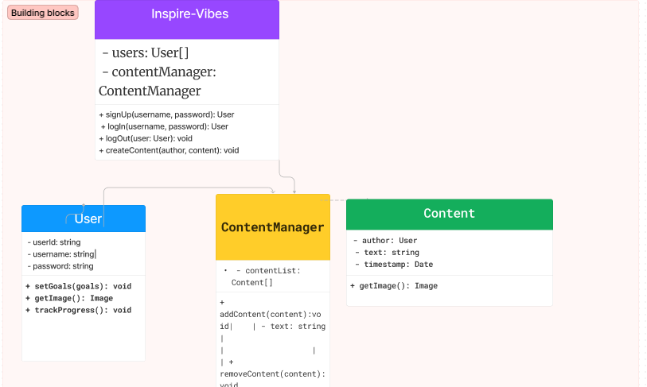

Class Descriptions:

• InspireVibes:

• Represents the main class for the InspireVibes platform.

• Manages users and the content management system.

• User:

• Represents a user of the InspireVibes platform.

• Holds information about the user, including their username, password, and goals.

• Participates in challenges, tracks progress, and interacts with content.

• ContentManager:

• Manages the content on the platform.

• Contains a list of content items and provides methods to add or remove content.

• Content:

• Represents individual pieces of content on the platform.

• Includes text, an author (User), a timestamp, and an optional image.

Relationships:

• The InspireVibes class has a composition relationship with User and ContentManager.

• The User class has associations with Content and ContentManager.

• The ContentManager class has an association with Content.

* 1. **USECASE DIAGRAMS**

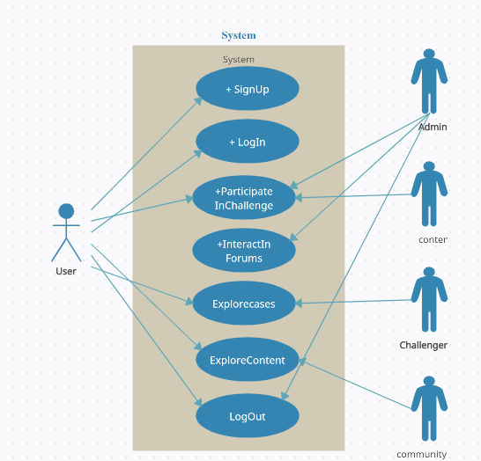

Use Case Descriptions:

User Management:

Use Cases:

* SignUp: Allows users to create an account.
* LogIn: Enables users to log into their accounts.
* LogOut: Allows users to log out of their accounts.
* Content Management:

Use Cases:

ExploreContent: Users can explore motivational content.

ParticipateInChallenge: Users can participate in challenges.

TrackProgress: Users can track their progress and goals.

Community Interaction:

Use Cases:

InteractInForums: Users can interact in community forums, share experiences, and engage in discussions.

Actors:

User: Represents the primary actor interacting with the InspireVibes platform.

Relationships:

The User actor is associated with the use cases, indicating the functionalities available to the user.

**INTERFACE(FINAL PROGRAM)**

1. **CODE**

**Main website code:**

**Front end :  
html:**

<!DOCTYPE html>

<html lang="en">

<head>

<meta charset="UTF-8">

<meta name="viewport" content="width=device-width, initial-scale=1.0">

<title>Document</title>

<link rel="stylesheet" href="loco.css">

<link href="https://cdn.jsdelivr.net/npm/remixicon@3.2.0/fonts/remixicon.css" rel="stylesheet">

<link rel="stylesheet" href="style.css"></link>

</head>

<body>

<div id="minicricle">

</div>

<div id="main">

<div id="hero">

<div id="nav">

<a href="menu/menu.html"><h2>MENU+</h2> <ul>

<a href="/profile/index.html"><img src="image-8.png" alt="">YOUR PROFILE</a>

</div>

<div id="heading">

<div class="bounding">

<h1 class="boundingelem">Inspire</h1>

</div>

<div id="blocktext">

<div class="bounding">

<h1 class="boundingelem" id="secondh1">Vibes</h1>

</div>

<div class="bounding">

<h5 class="boundingelem">made in india ❤ </h5>

</div>

</div>

</div>

<div id="chootiheading">

<div class="bounding">

<h5 class="boundingelem">BE-BETTER</h5>

</div>

<div class="bounding">

<h5 class="boundingelem">BE-YOU</h5>

</div>

</div>

<div id="herofooter">

<a href="#">SHARE YOUR THOUGHTS<i class="ri-arrow-right-up-line"></i> </a>

<a href="#">NEED MOTIVATION <i class="ri-arrow-right-up-line"></i> </a>

<div id="iconset">

<div class="circle"><i class="ri-arrow-up-line"></i></div>

<div class="circle"><i class="ri-arrow-down-line"></i></div>

</div>

</div>

</div>

</div>

</div>

<script src="https://cdnjs.cloudflare.com/ajax/libs/gsap/3.12.3/gsap.min.js"></script>

<script src="https://cdn.jsdelivr.net/npm/locomotive-scroll@3.5.4/dist/locomotive-scroll.min.js"></script>

<script src="script.js"></script>

</body>

</html>

Css:

*{

margin:0;

padding:0;

box-sizing: border-box;

font-family: "General Sans";

}

html,body{

width: 100%;

height: 100%;

}

#minicricle{

transition: all cubic-bezier(0.19,1,0.22,1) 1s;

width: 10px;

height: 10px;

background-color: #fff;

position: absolute;

z-index: 9999;

border-radius: 50%;

}

.bounding{

width:fit-content;

/* background: red; */

overflow: hidden;

}

.bounding .boundingelem{

transform: translateY(100%);

}

#main{

width: 100%;

background-color: black;

}

#hero{

color: #fff;

width: 100%;

height: 100vh;

background-color: black;

position: relative;

}

#nav{

width: 100%;

padding:20px 40px;

color:#fff;

display: flex;

align-items: center;

justify-content: space-between;

}

#nav a{

font-size:18px;

color: #fff;

text-decoration: none;

}

#nav img{

height: 26px;

}

#heading{

margin-top: 90px;

}

#heading h1{

font-size:10vw;

text-transform: uppercase;

font-weight: 900;

line-height: 1;

opacity: 0.6;

margin-left: 230px;

}

#heading #secondh1{

margin-left: 430px;

}

#blocktext{

display: flex;

flex-direction: column;

align-items: end;

width: fit-content;

}

#blocktext h5{

text-transform: uppercase;

text-align: right !important;

font-size: 15px;

}

#chootiheading{

display: flex;

flex-direction: column;

align-items: end;

margin-top: 100px;

padding-right:50px;

}

#chootiheading h5{

text-transform: uppercase;

text-align: right;

font-size: 1vw;

margin-top:.5vw;

}

#herofooter{

bottom: 3%;

display: flex;

align-items: center;

justify-content: space-between;

width: 100%;

position:absolute;

padding: 0 2vw;

}

#herofooter a{

color: #fff;

text-transform: uppercase;

text-decoration: none;

}

#herofooter .circle{

display: flex;

align-items: center;

width: 25px;

height: 25px;

background-color: #888;

border-radius: 50%;

}

#herofooter #iconset{

display: flex;

gap:5px;

}

#second{

padding-right: 10vw;

padding-top: 200px;

width: 100%;

height: 100vh;

color: #fff;

background-color: black;

}

.elem{

position: relative;

width: 100%;

border-top:1px solid white;

padding: 3.5vw 3vw;

padding-right: 0;

display: flex;

align-items: center;

justify-content: space-between

.elem h1{

text-transform: uppercase;

font-size: 8vw;

opacity: 0.7;

}

.elemlast{

border-bottom: 1px solid white;

}

.elem img{

opacity: 0;

pointer-events: none;

height: 140%;

z-index: 999;

position: absolute;

transform: translate(-50%, -50%);

}

#about{

display:flex;

align-items: center;

/* justify-content: space-between; */

gap:30px;

color: #fff;

margin: 20vw;

padding: 10vw 10vw;

padding-left:0vw;

width:auto;

background-color: black;

margin-bottom:2vw ;

}

#textabout p

padding: 12px 22px;

border: 1px solid #fff;

border-radius:100px;

circleMousefollower(xscale,yscale);

timeout = setTimeout(function(){

document.querySelector("#minicricle").style.transform = translate(${dets.clientX}px, ${dets.clientY}px) scale(1,1);

}, 100);

function circleMousefollower(xscale,yscale){

window.addEventListener("mousemove",function(dets){

// console.log(dets.clientX,dets.clientY);

document.querySelector("#minicricle").style.transform = translate(${dets.clientX}px, ${dets.clientY}px) scale(${xscale},${yscale});

})

}

circleMousefollower();

document.querySelectorAll(".elem").forEach(function(elem)

{

var rotate = 0;

var diffrot = 0;

gsap.to(elem.querySelector("img"), {

opacity:0,

ease: Power3,

duration:0.5,

});

});

**backend:**

**Nodejs:**

{

"name": "inspire-vibe",

"version": "1.0.0",

"lockfileVersion": 1,

"requires": true,

"dependencies": {

"@babel/code-frame": {

"version": "7.10.4",

"resolved": "https://registry.npmjs.org/@babel/code-frame/-/code-frame-7.10.4.tgz",

"integrity": "sha512-vG6SvB6oYEhvgisZNFRmRCUkLz11c7rp+tbNTynGqc6mS1d5ATd/sGyV6W0KZZnXRKMTzZDRgQT3Ou9jhpAfUg==",

"dev": true,

"requires": {

"@babel/highlight": "^7.10.4"

}

},

"@babel/helper-validator-identifier": {

"version": "7.10.4",

"resolved": "https://registry.npmjs.org/@babel/helper-validator-identifier/-/helper-validator-identifier-7.10.4.tgz",

"integrity": "sha512-3U9y+43hz7ZM+rzG24Qe2mufW5KhvFg/NhnNph+i9mgCtdTCtMJuI1TMkrI

"@babel/highlight": {

"version": "7.10.4",

"resolved": "https://registry.npmjs.org/@babel/highlight/-/highlight-7.10.4.tgz",

"dev": true,

"requires": {

"@babel/helper-validator-identifier": "^7.10.4",

"chalk": "^2.0.0",

"js-tokens": "^4.0.0"

"@sindresorhus/is": {

"version": "0.14.0",

"resolved": "https://registry.npmjs.org/@sindresorhus/is/-/is-0.14.0.tgz",

"integrity": "sha512-9NET910DNaIPngYnLLPeg+Ogzqsi9uM4mSboU5y6p8S5DzMTVEsJZrawi+BoDNUVBa2DhJqQYUFvMDfgU062LQ==",

"dev": true

},

"@szmarczak/http-timer": {

"version": "1.1.2",

"resolved": "https://registry.npmjs.org/@szmarczak/http-timer/-/http-timer-1.1.2.tgz",

"integrity": "sha512-XIB2XbzHTN6ieIjfIMV9hlVcfPU26s2vafYWQcZHWXHOxiaRZYEDKEwdl129Zyg50+foYV2jCgtrqSA6qNuNSA==",

"dev": true,

"requires": {

"defer-to-connect": "^1.0.1"

}

},

"abbrev": {

"version": "1.1.1",

"resolved": "https://registry.npmjs.org/abbrev/-/abbrev-1.1.1.tgz",

"integrity": "sha512-nne9/IiQ/hzIhY6pdDnbBtz7DjPTKrY00P/zvPSm5pOFkl6xuGrGnXn/VtTNNfNtAfZ9/1RtehkszU9qcTii0Q==",

"dev": true

},

"accepts": {

"version": "1.3.7",

"resolved": "https://registry.npmjs.org/accepts/-/accepts-1.3.7.tgz",

"integrity": "sha512-Il80Qs2WjYlJIBNzNkK6KYqlVMTbZLXgHx2oT0pU/fjRHyEp+PEfEPY0R3WCwAGVOtauxh1hOxNgIf5bv7dQpA==",

"requires": {

"mime-types": "~2.1.24",

"negotiator": "0.6.2"

}

},

"acorn": {

"version": "7.4.1",

"resolved": "https://registry.npmjs.org/acorn/-/acorn-7.4.1.tgz",

"integrity": "sha512-nQyp0o1/mNdbTO1PO6kHkwSrmgZ0MT/jCCpNiwbUjGoRN4dlBhqJtoQuCnEOKzgTVwg0ZWiCoQy6SxMebQVh8A==",

"dev": true

},

"acorn-jsx": {

"version": "5.3.1",

"resolved": "https://registry.npmjs.org/acorn-jsx/-/acorn-jsx-5.3.1.tgz",

"integrity": "sha512-K0Ptm/47OKfQRpNQ2J/oIN/3QYiK6FwW+eJbILhsdxh2WTLdl+30o8aGdTbm5JbffpFFAg/g+zi1E+jvJha5ng==",

"dev": true

},

"after": {

"version": "0.8.2",

"resolved": "https://registry.npmjs.org/after/-/after-0.8.2.tgz",

"integrity": "sha1-/ts5T58OAqqXaOcCvaI7UF+ufh8="

},

**OUTPUT(ATTACHMENTS OF WEBSITE)**

**Login page**

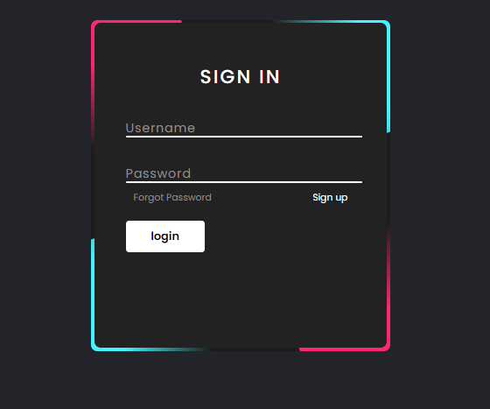

**Homepage**

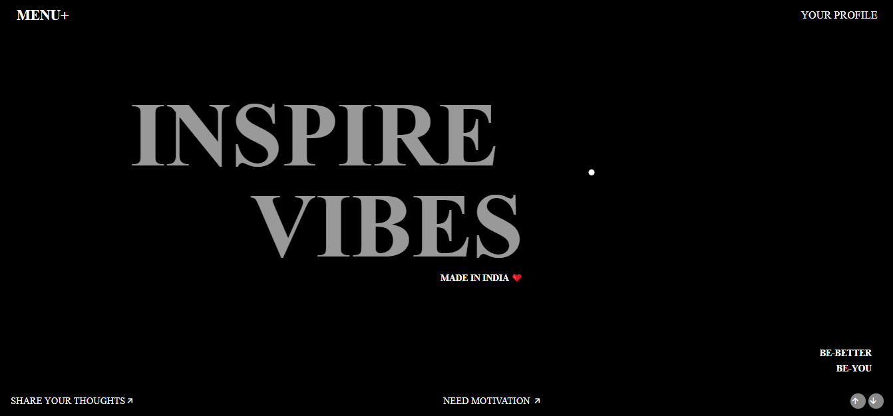

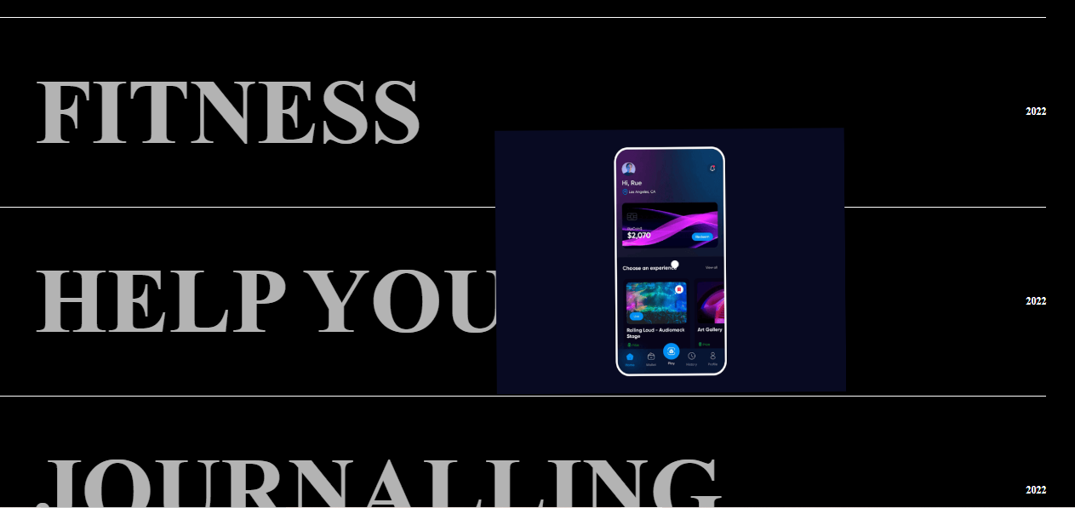

**TESTING**

Unit Testing:

Test individual components or functions to ensure they behave as expected.

Utilize testing frameworks compatible with your programming language or framework.

Integration Testing:

Test the interaction between different components or modules to ensure they work together seamlessly.

End-to-End (E2E) Testing:

Conduct tests that simulate real user scenarios, covering the entire application workflow.

Use tools like Selenium, Cypress, or Puppeteer for web applications.

User Acceptance Testing (UAT):

Involve actual users or stakeholders to validate that the system meets their requirements.

Gather feedback on usability, functionality, and overall user experience.